**Question 1 :** **Provide a summary of the main concepts about solar radiation:**

1. **Solar Radiation:** it is an electromagnetic radiative energy that is emitted from the sun which is an unlimited source of energy. The earth receives an abundant amount of energy from the sun daily and this received energy is called Incident Solar Radiation, or Insolation.
2. 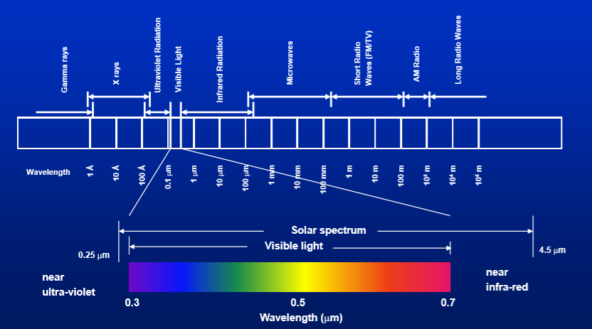**The Solar Radiation Density:** it is the amount of solar radiation energy received by a surface (in outer space or on the earth’s surface), it varies due to the angle and distance. The solar Irradiance, or the sun’s radiant power is represented in W/m2 or kW/m2. The Solar Constant is the average value of solar irradiance in outer space. The solar irradiance of a surface placed in outer space and is perpendicular to the sun is 1367 W/m2. If it is on the Earth’s perpendicular surface then it is 1000 W/m2.
3. **Solar Radiation Spectrum:** the wavelength spectrum ranges from 0.3 to 2.5 micrometer (visible and invisible) including the ultraviolet, the visible light and the infrared light.
4. 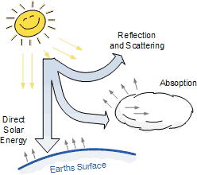**Solar Radiation Characteristics:** it travels through the atmosphere in order to reach the earth’s surface and though that travel distance the intensity changes, called attenuation, due to the phenomena of scattering and surface absorption and reflection so the solar power reaches earth less than it used to be. It depends on the altitude, latitude, time of the day and year and air and the wavelength of the solar radiation.
5. 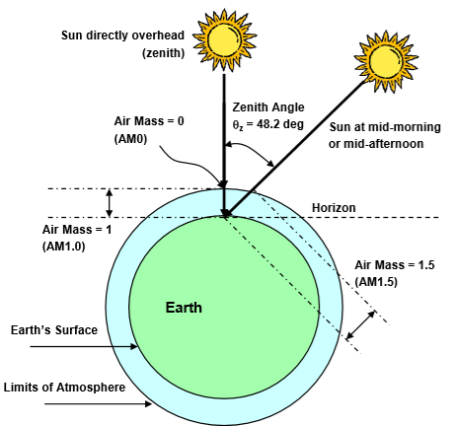**Direct (Beam) Radiation:** it is the solar radiation that has not been intercepted that traveled in parallel lines from the sun (total solar radiation indecent on a surface)**.**
6. **Diffuse Radiation:** it is the solar radiation that is indecent on a surface that is scattered or reflected, deflected in all direction due to the intercepted surface/molecule.
7. **Atmospheric Absorption:** there are components in the atmosphere that (ozone, water and carbon dioxide) that absorb incident radiation and ten changing their wavelength spectrum and then reemit it in all directions (ultraviolet and infrared).
8. 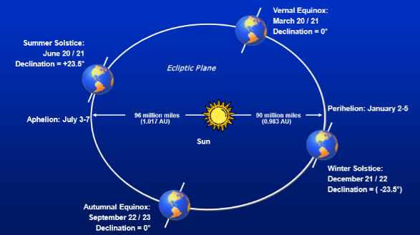**Air Mass:** when the sun is perpendicular (zenith angle) to the earth (thickness of atmosphere layer), less sun travels through than if sun travels at an angle.
9. **Solar Energy: Availability:** solar radiation when it reaches Earth in order for it to change into another energy form depends on the position of the sun and its angle, the weather and the location in relation to the sea level.
10. 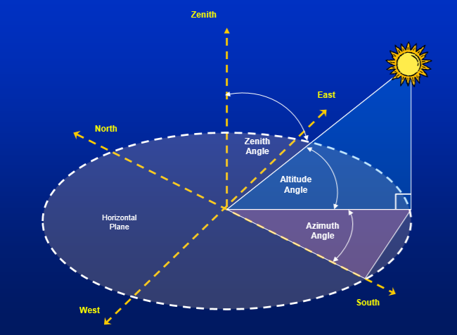**The terrestrial axis inclination:** it describes the axis at which the sun is at 23.5 degrees on the earth which is on December 21 and June 21 (summer and winter solstice).
11. **Solar Height and Solar zenith angle:** the solar height is the difference between the angle of the sun ray and the earth surface.
12. **Radiation Density on “tilted” Surface:** as mentioned above the distribution of the solar radiation (sun flux) is larger when it is at a titled angle, the more titled the larger the distribution.
13. **Measurement Instruments:** the pyranometer is the tool used to measure the solar power and it has different types to measure certain aspects. A pyranometer is used to measure the solar irradiance (solar power) direct and diffused. A N pyranometer with a shadow band is used to measure the diffused irradiance only, the Normal pyrheliometer is used to measure the direct solar radiation**.**

**Question 2:** **Summary of Open Studio to change Wall set up:**

To carry on from the saved file, we will start by opening OpenStudio and then open the weather file and then the ddy file to add all the information regarding the chosen location.

The difference between both files is that the weather file just gives you the yearly temperature and all the ddy file gives you the worst case scenarios in summer and winter and gives you the setup of the required wall loads and materials for the selected function , ex. Office.

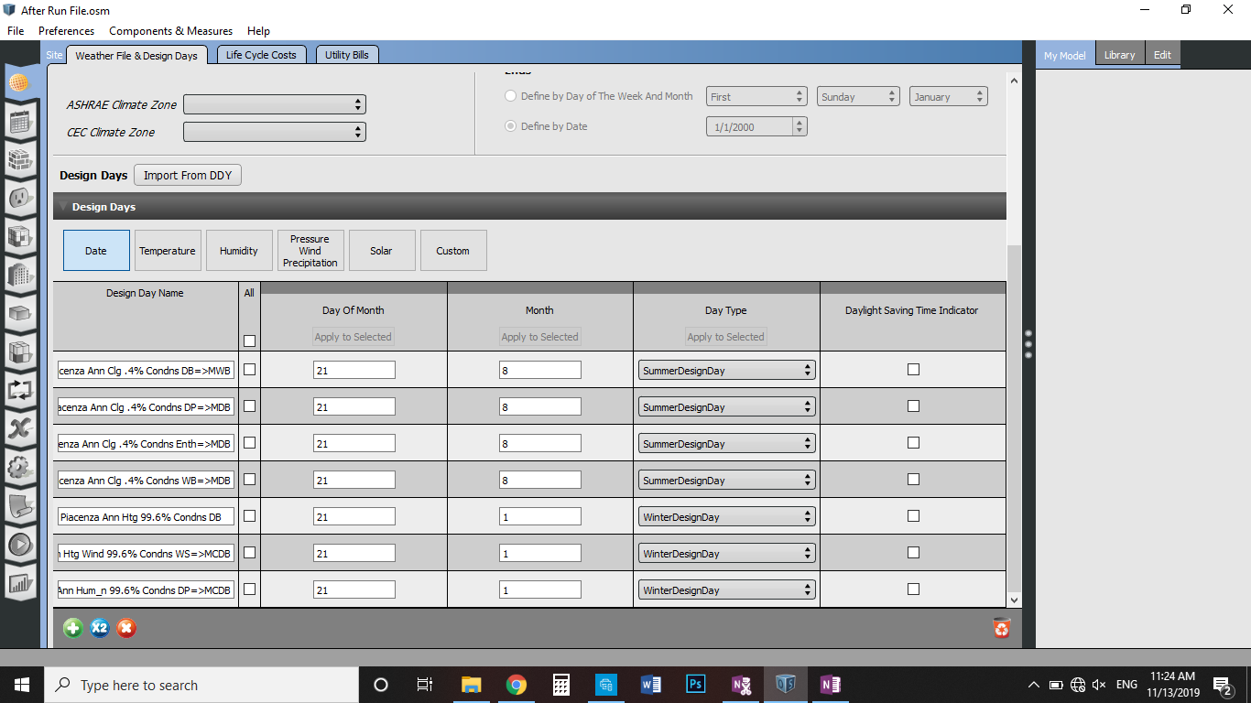

--worst day in Piacenza ---- in summer

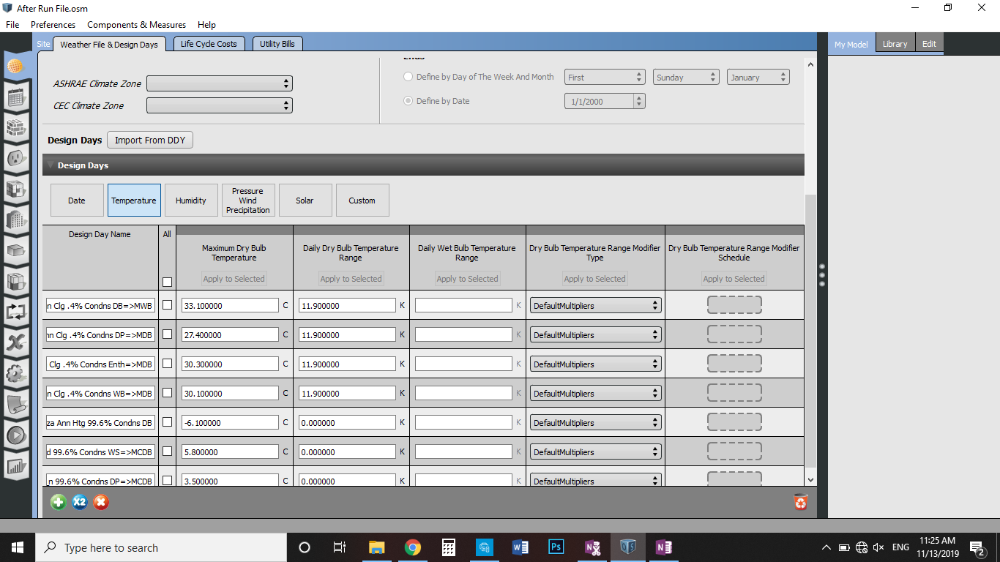

Change to temp tab to know the temperatures

We didn’t specify the thickness of the wall or the number of people in the space

So when choosing the thermal zone and the space type it gave an average of the wall thickness and the average temperature with the equipment

**Today we change the pre-defined construction data and try to apply these schedules on the building.**

**To define the construction sets -- go to the third tab**

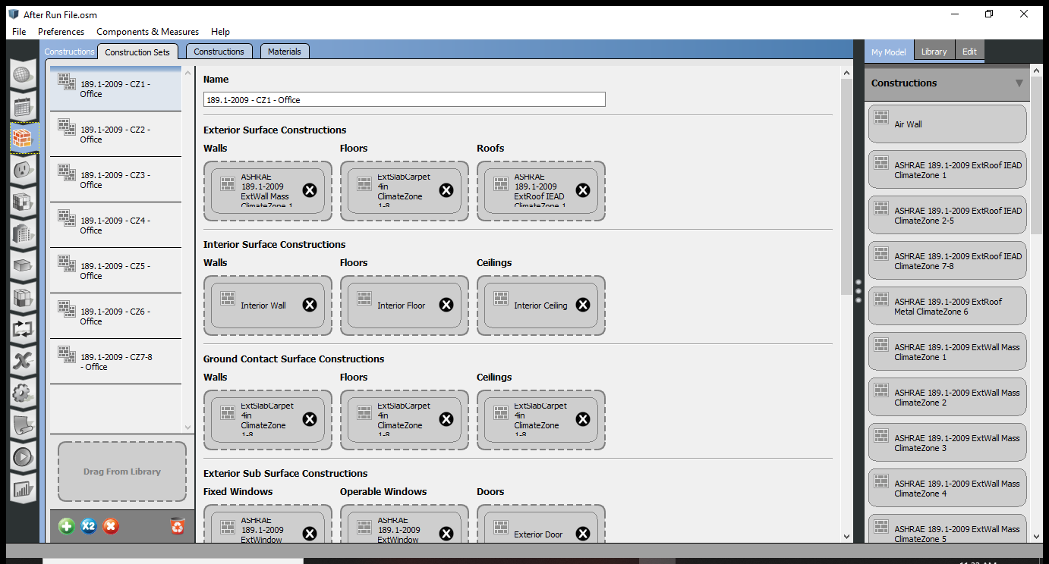

**Difference between constructions and c. sets -- it has the wall defined walls, floors windows and all**

**Sets are the details of every element of the set.**

**Never start from scratch, choose something similar and start modifying the set so that the base of the chosen items are correct and help the simulation to run correctly.**

**How to duplicate**

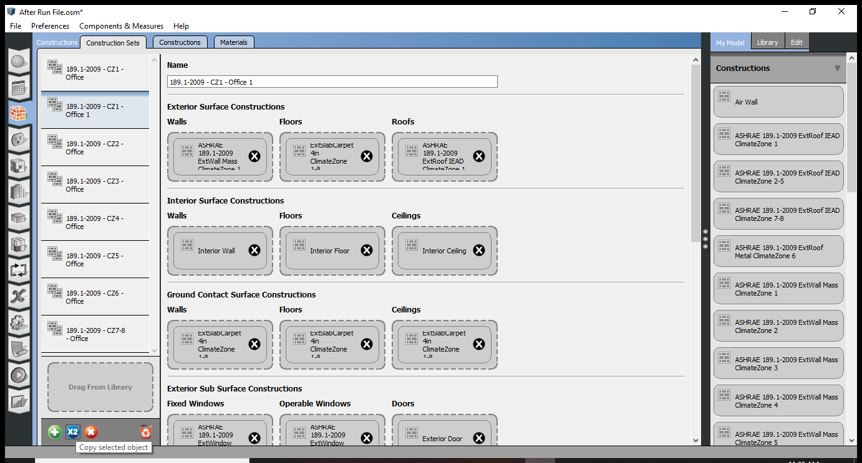

**Then rename the duplicated file**

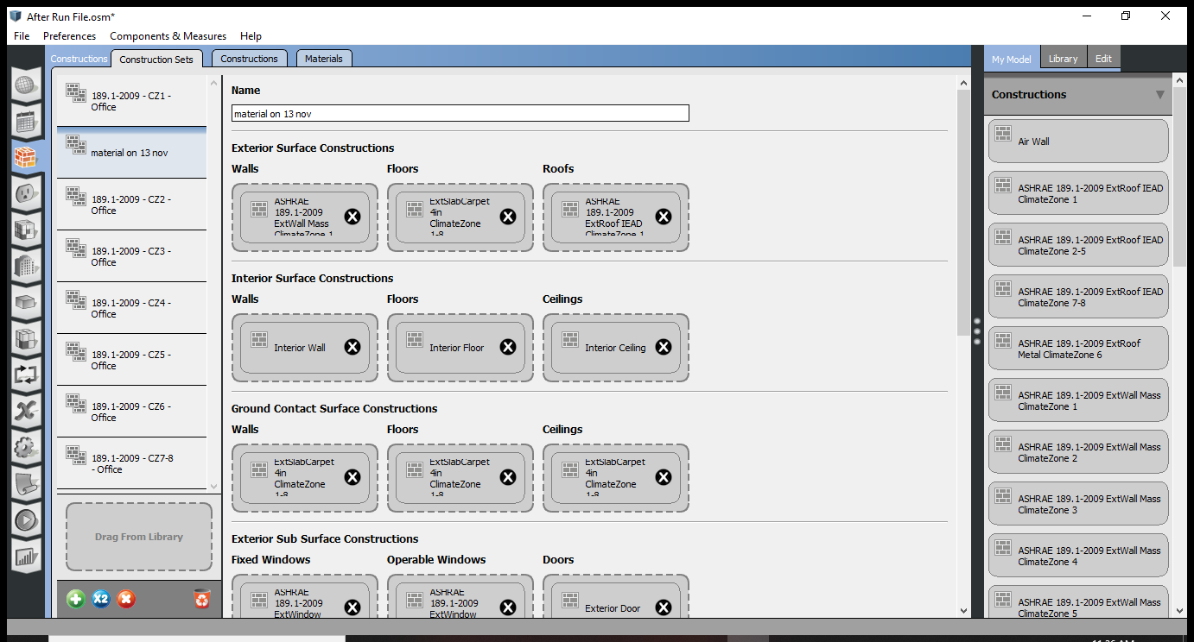

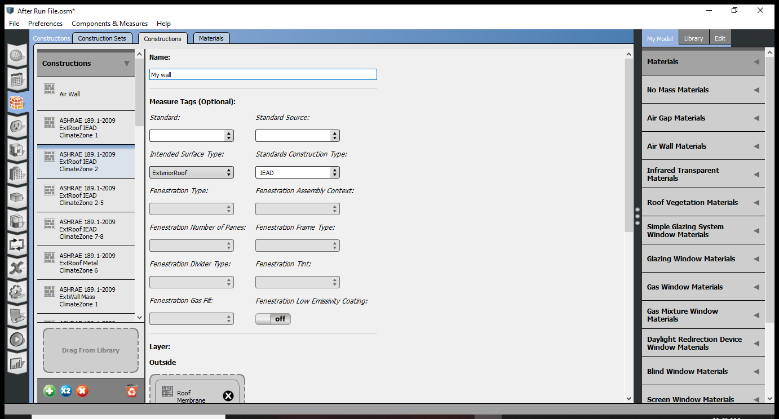

**Duplicate then rename then go down and remove all materials**

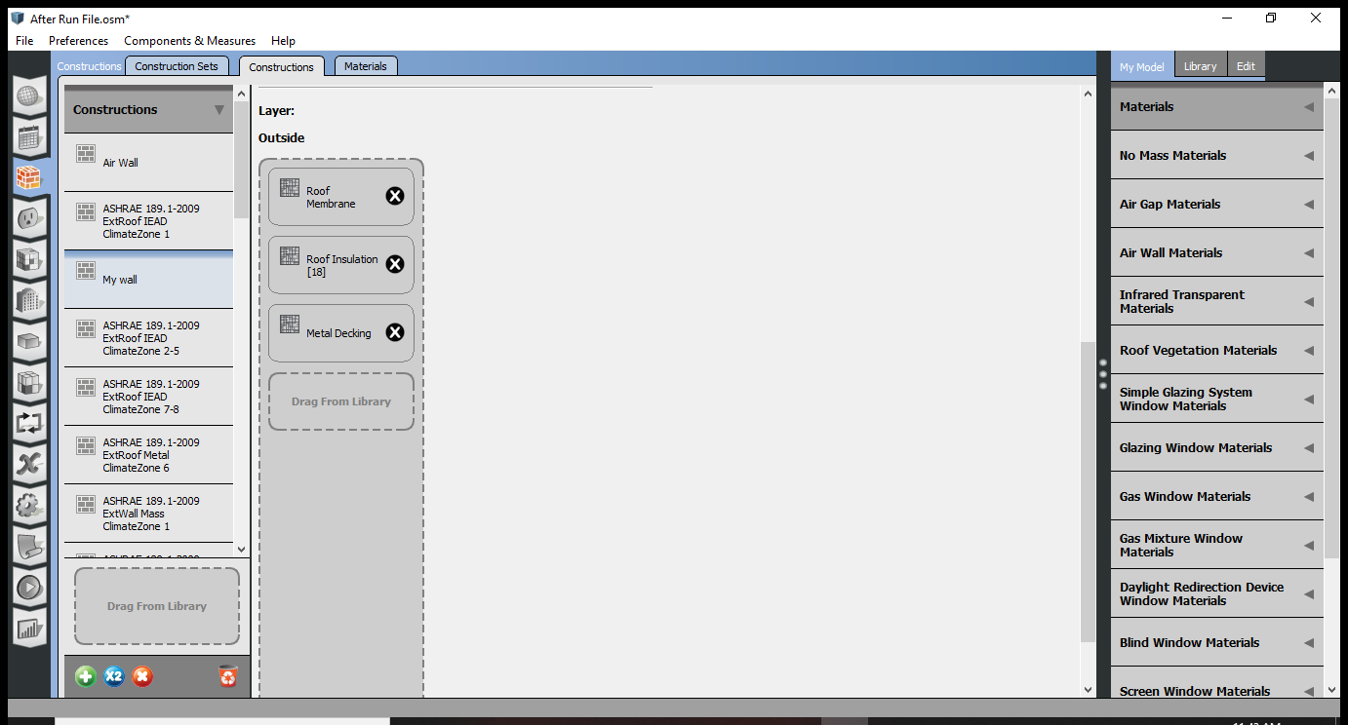

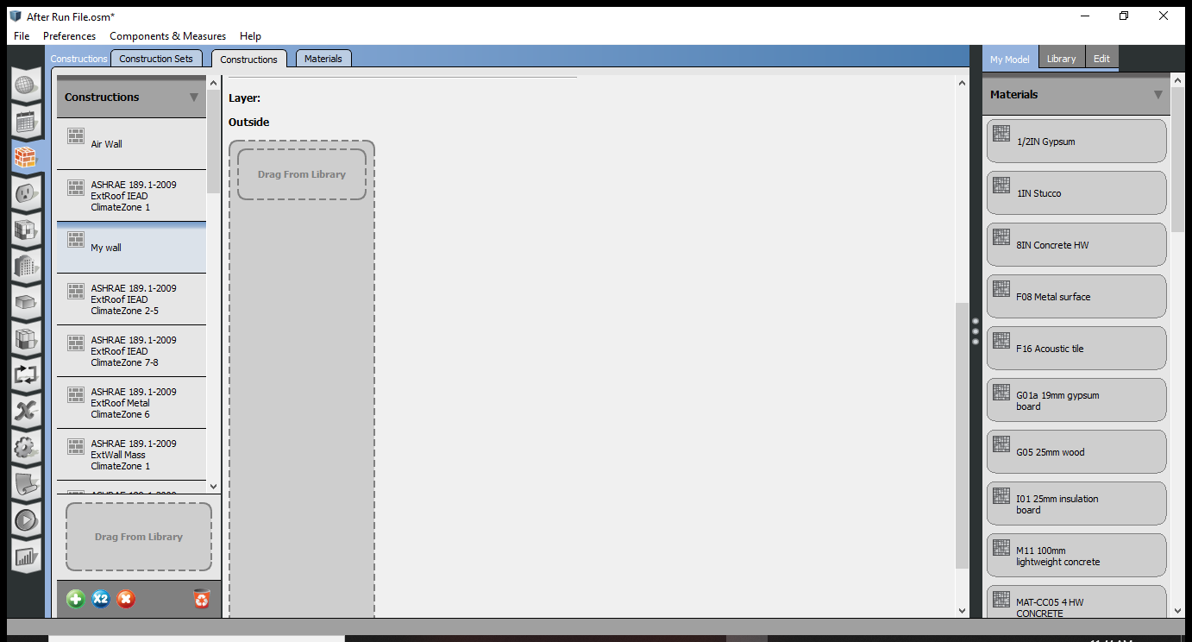

**Choose the materials and then drag materials form the right menu under materials**

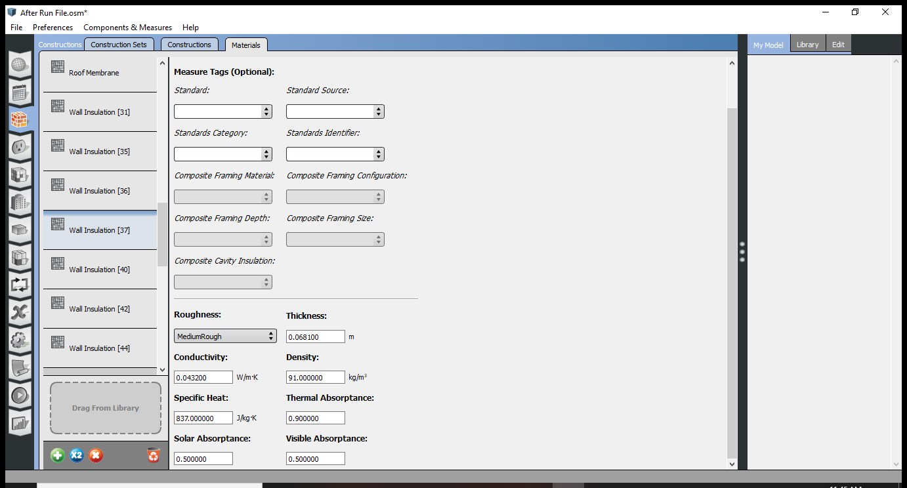

**Change tab to materials and then go to materials drop down menu on the left and then choose to material and you can see what it is made of and you can change it.**

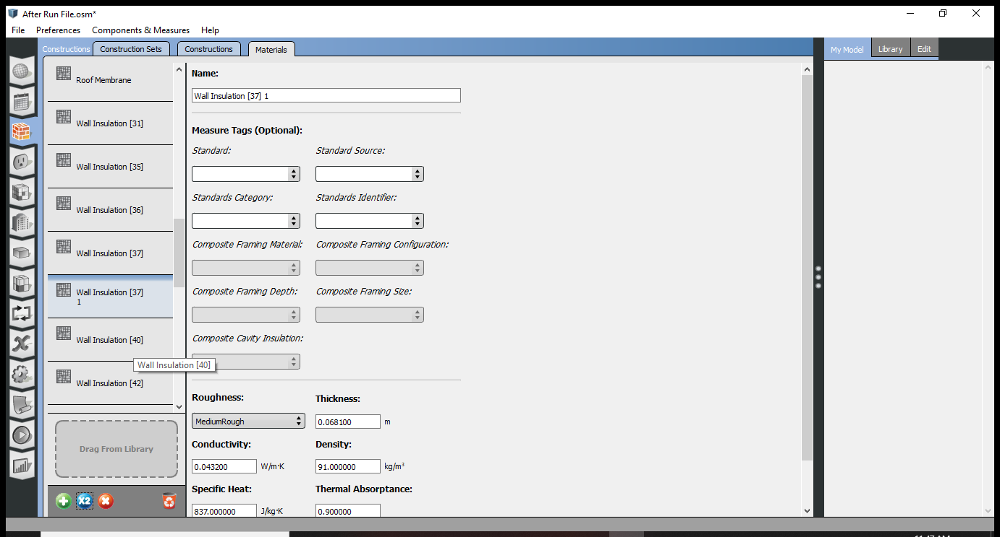

**Duplicate the wall insulation in order to change it**

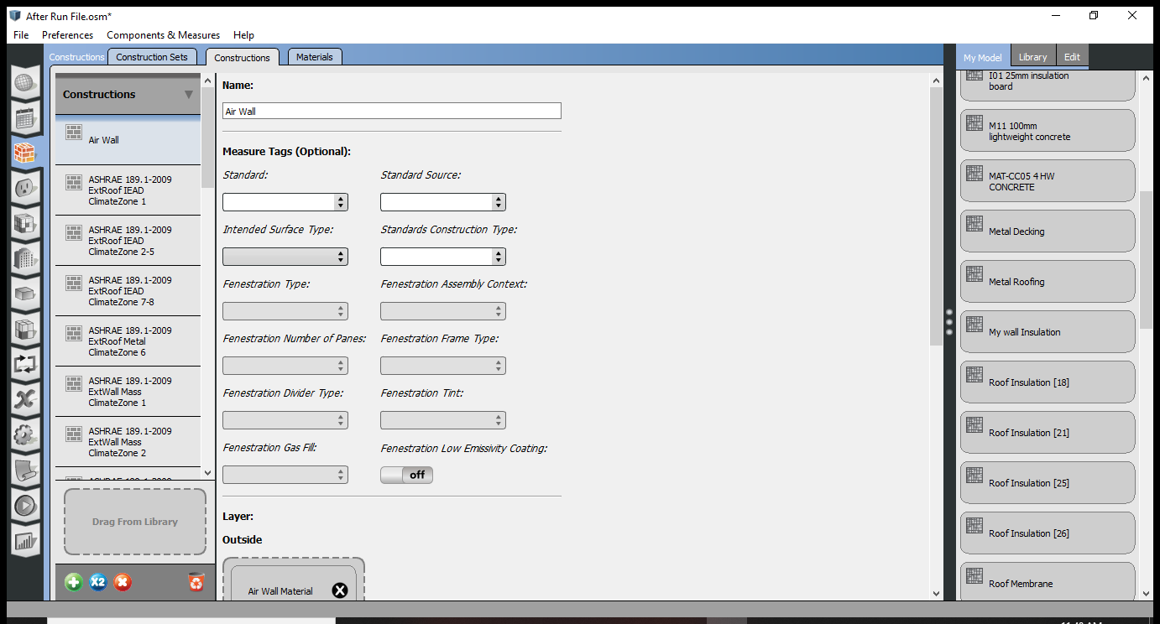

Go back to constructions Tab and then look for the custom wall and then drag it in the mateials list

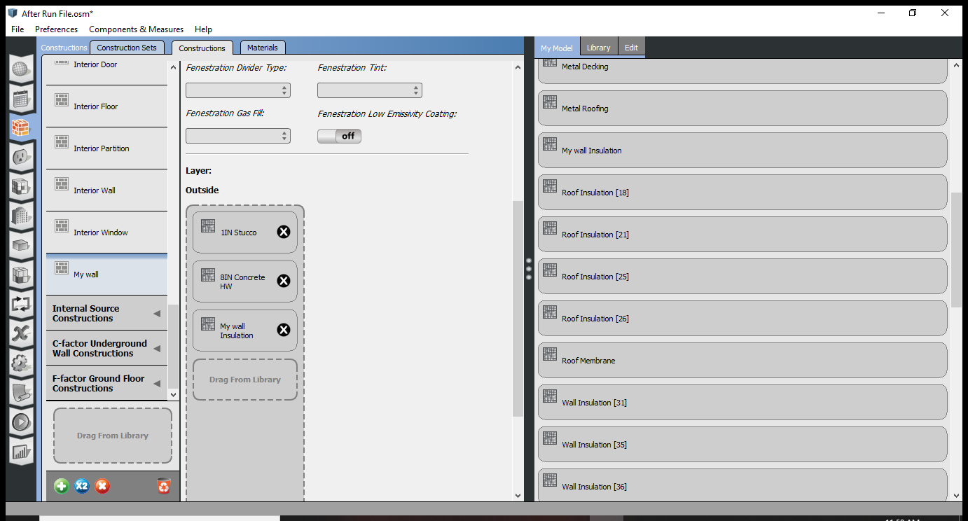

Open my wall design and then choose the wall insulation that I made

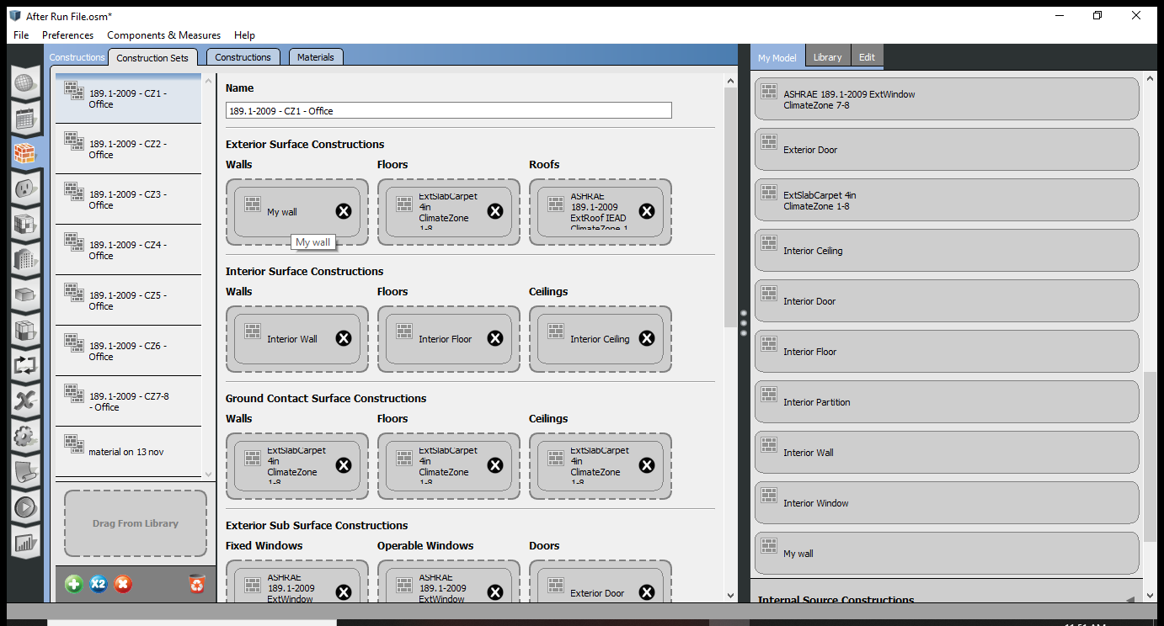

Then go to construction sets tab remove the existing wall and add my wall design

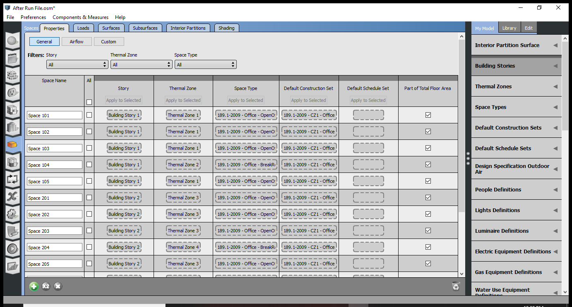

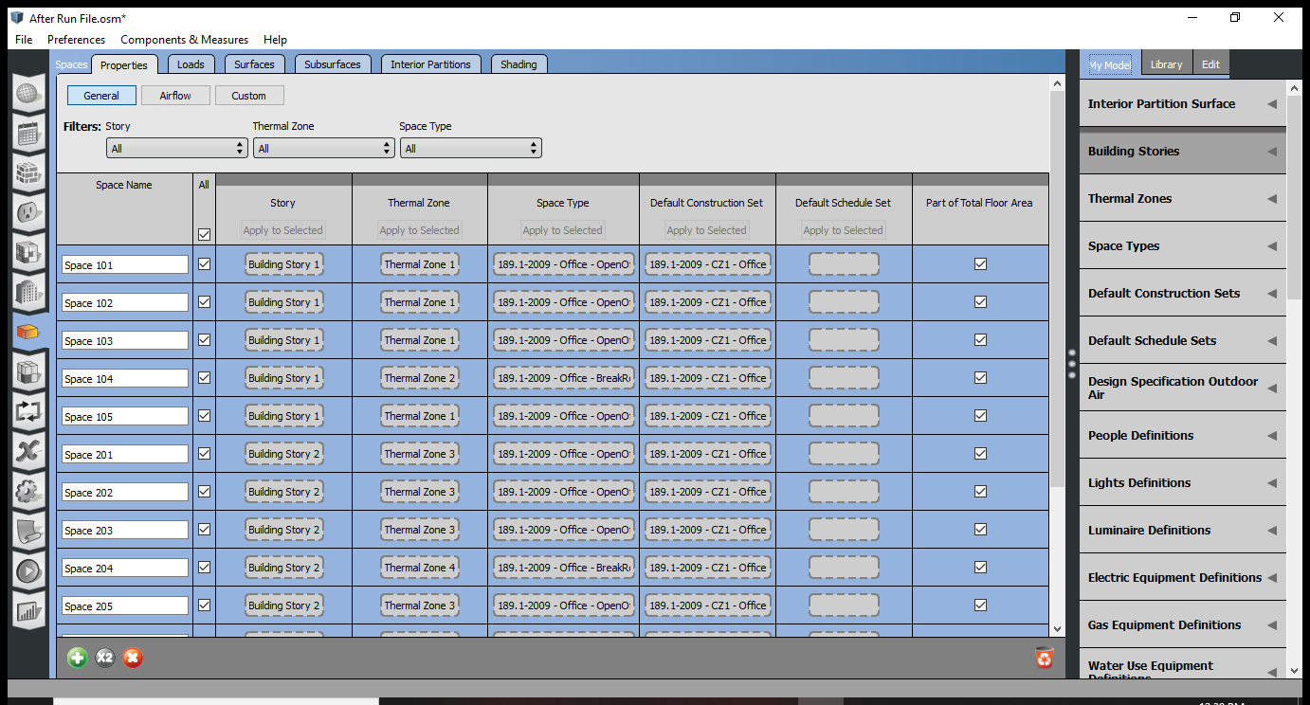

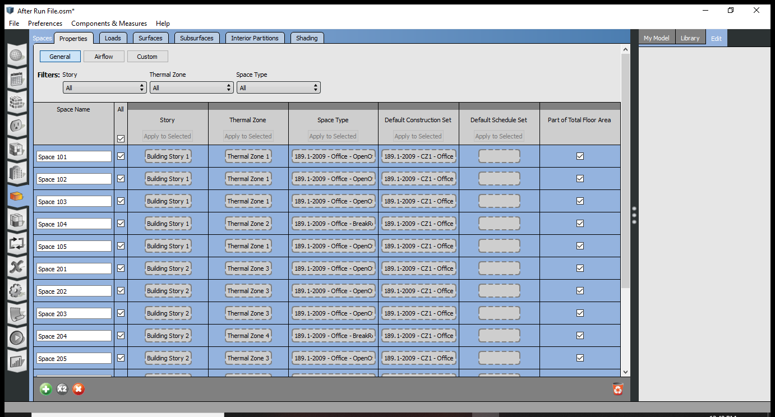

Then select apply to selected so that it changes your wall into the new designed one.

Now when I want to apply the info on people

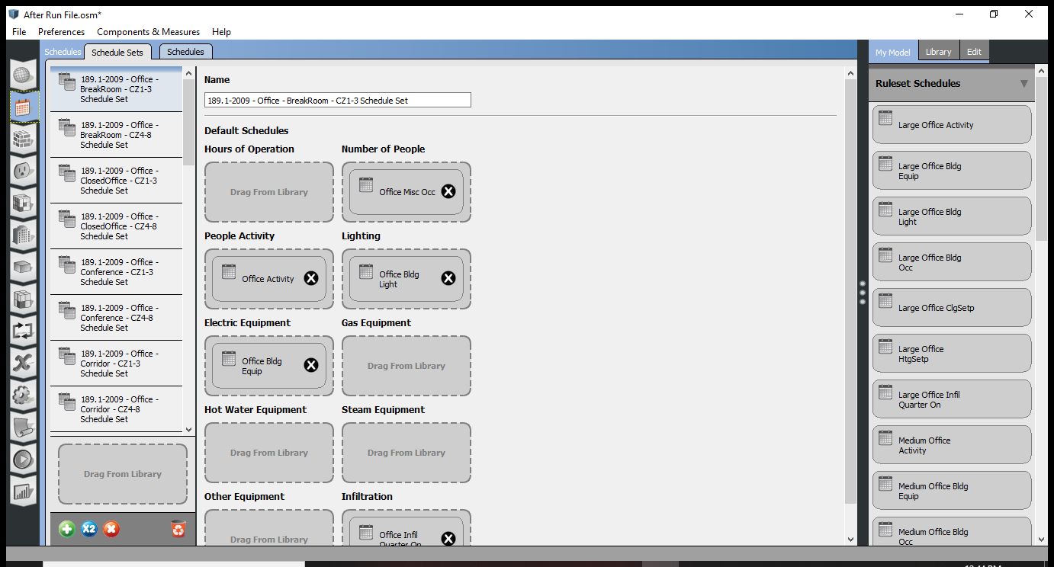

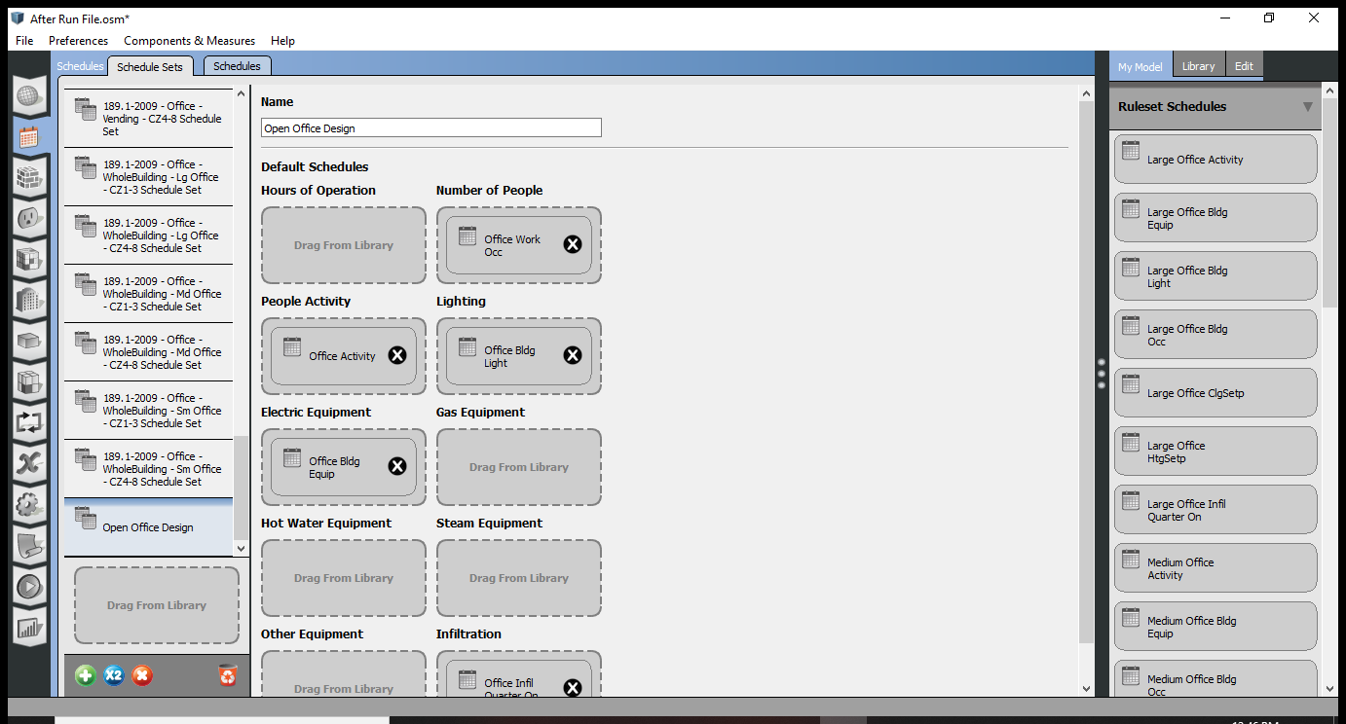

Duplicate and save then Open tab of shchduels

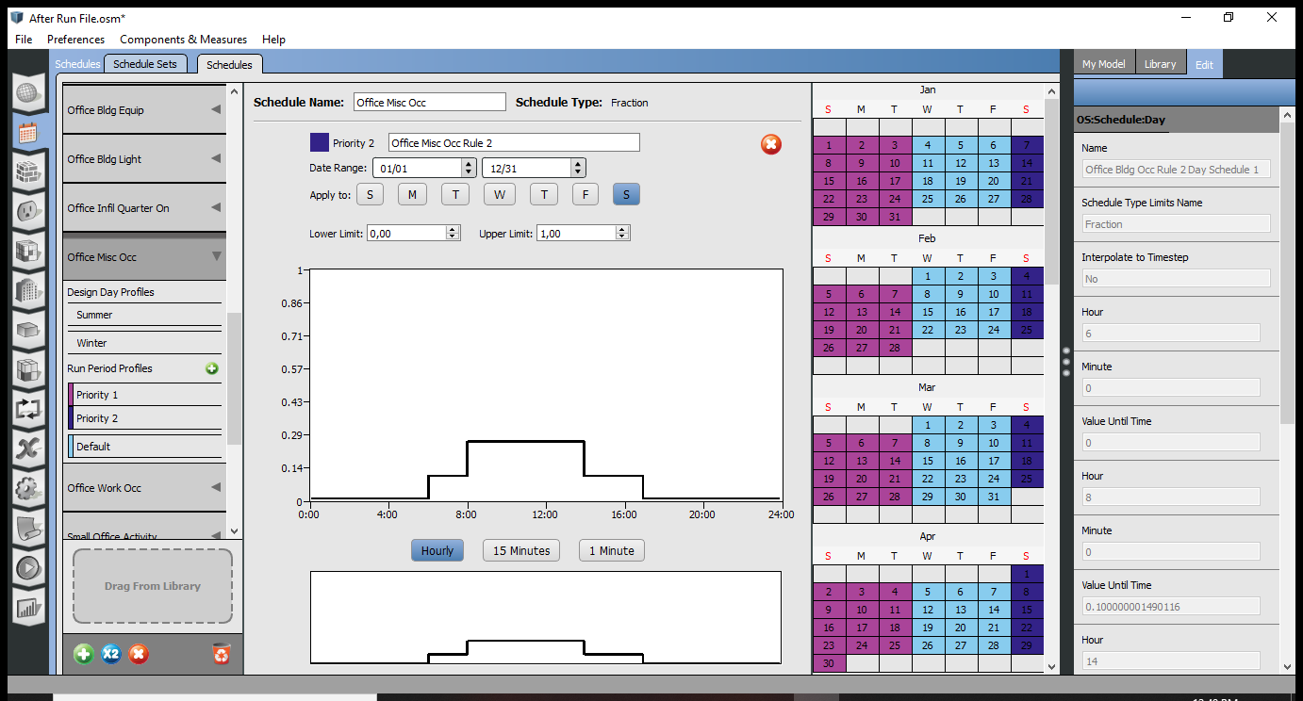

Choose the office occ misc, means people in the office

You can double click on the lines to change the active hours

Priority means (1 and 2), are the scenarios, weekdays vs weekends for example.

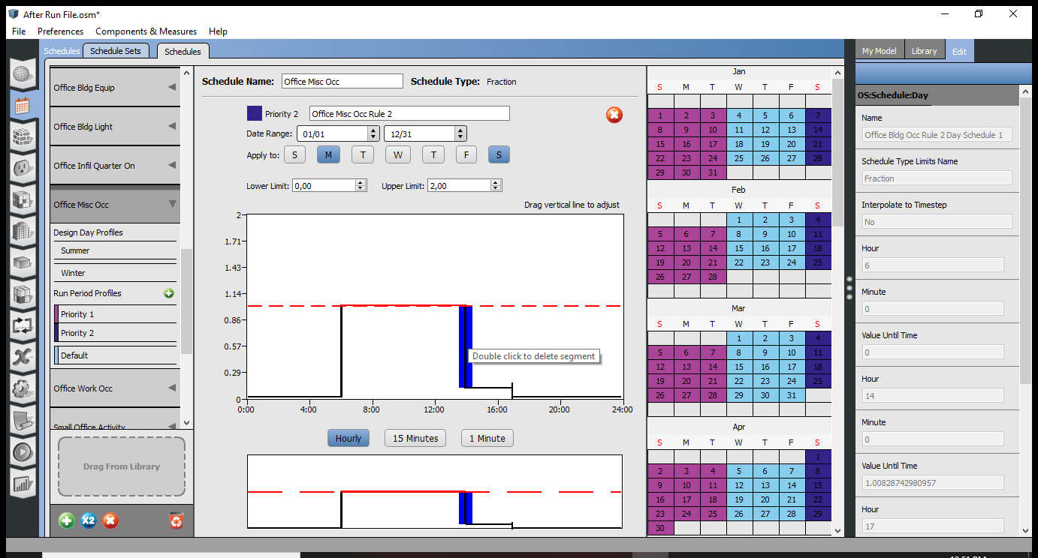

You can change whatever you want so that you can create your own office hours.

Worst case scenarios

Summer: stuffy room with long office hours and a lot of people are there

Winter: no one in the room because if there are people there they would help making the room warmer.

The data is watts per person

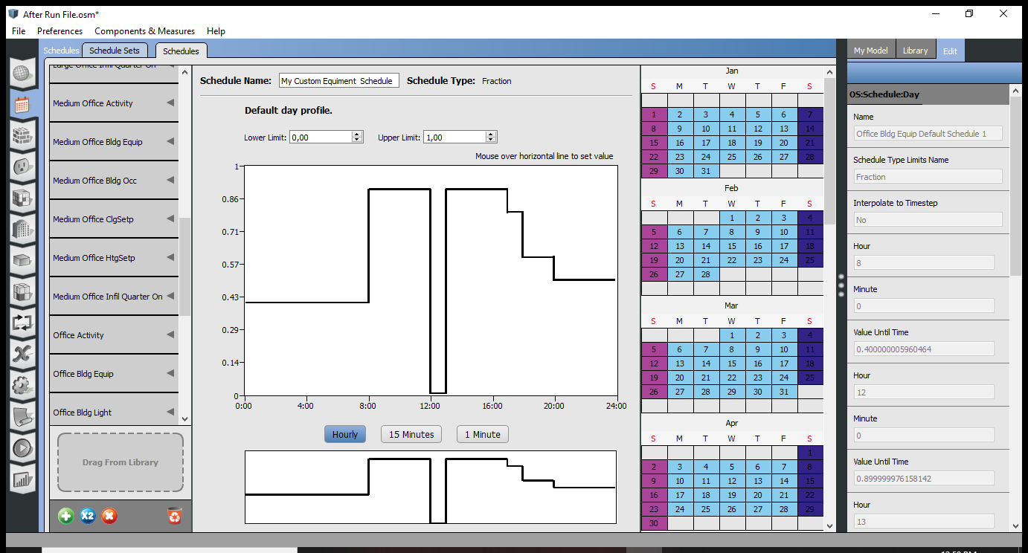

Duplicate the office equipment tab and change the office hours

If you double click on the vertical lines to remove them

Define the schedule go to my model and

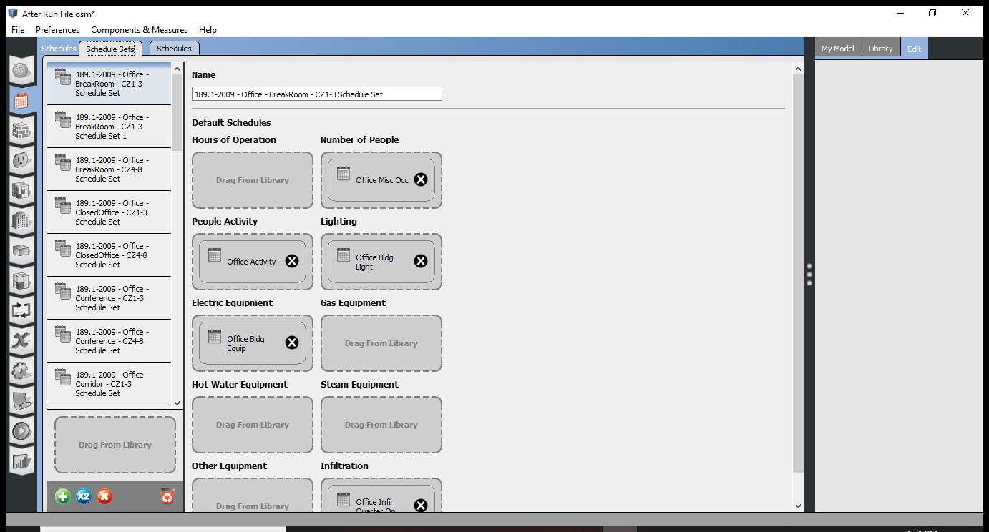

Go to the schedule set up and change the number of people,, People activity, lighting and equipment and add yours

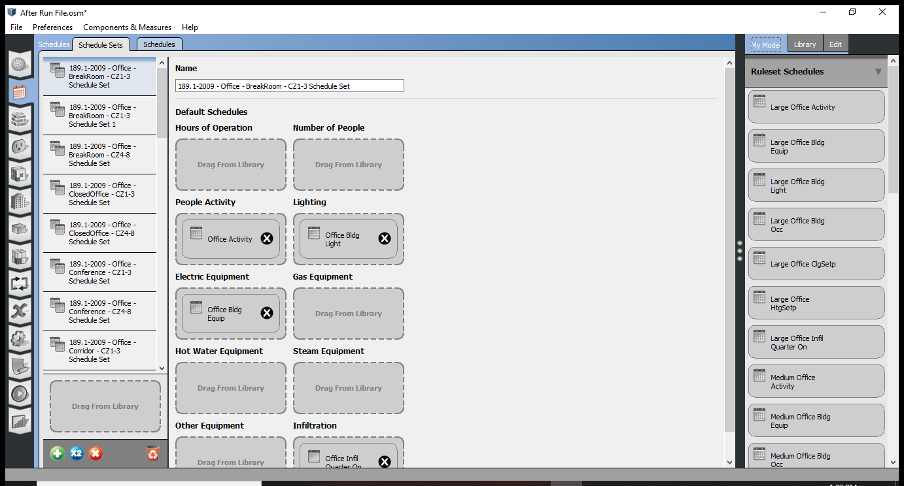

Click on my model tab and then remove the defaults and pick your custom sets

How to apply the sets to the spaces

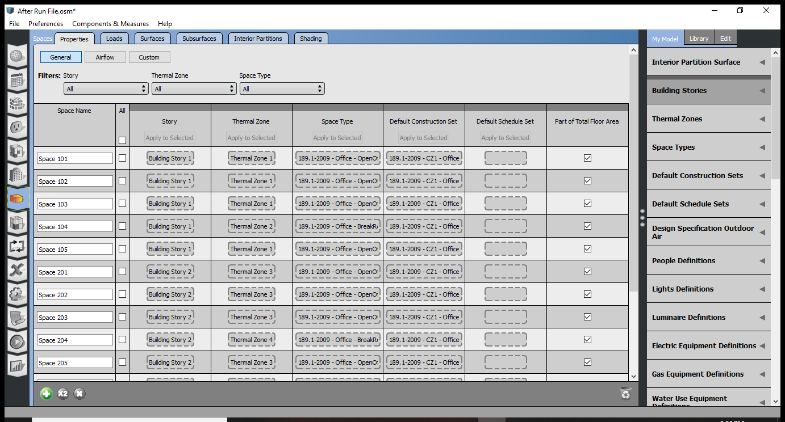

Go to spaces tab

Go to the loads tab

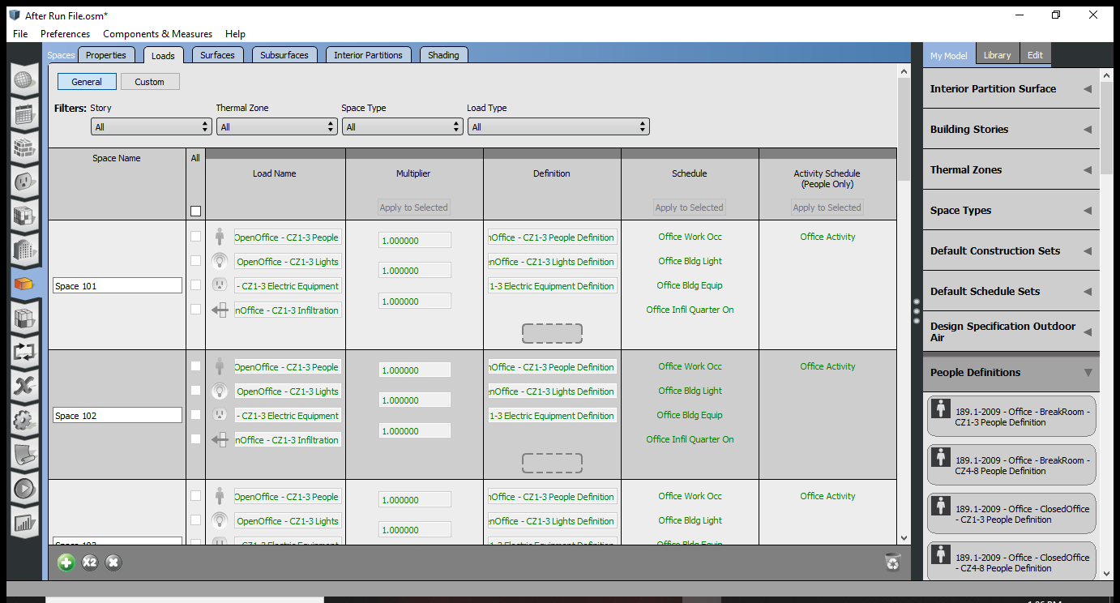

Then select people definitions

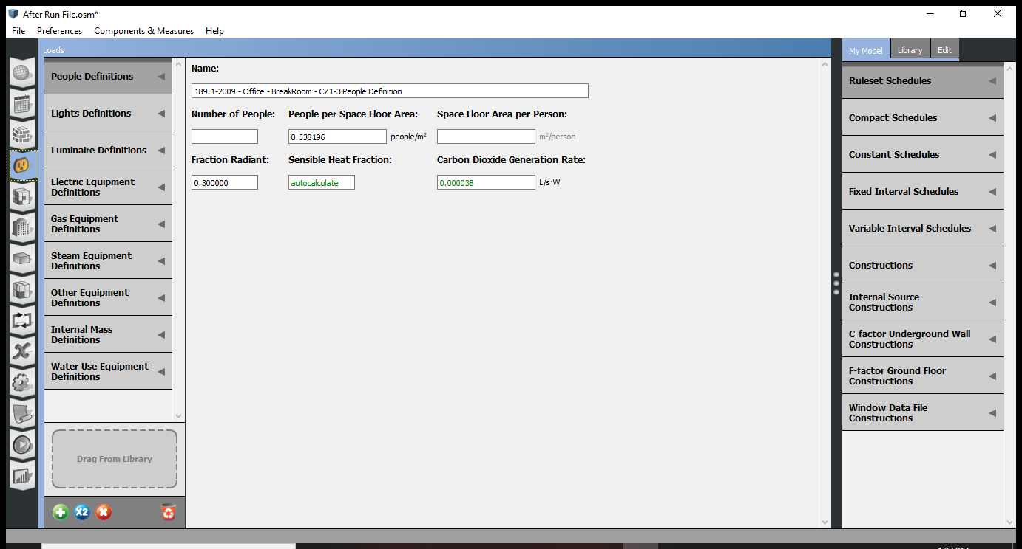

Then select the people def. to see the loads

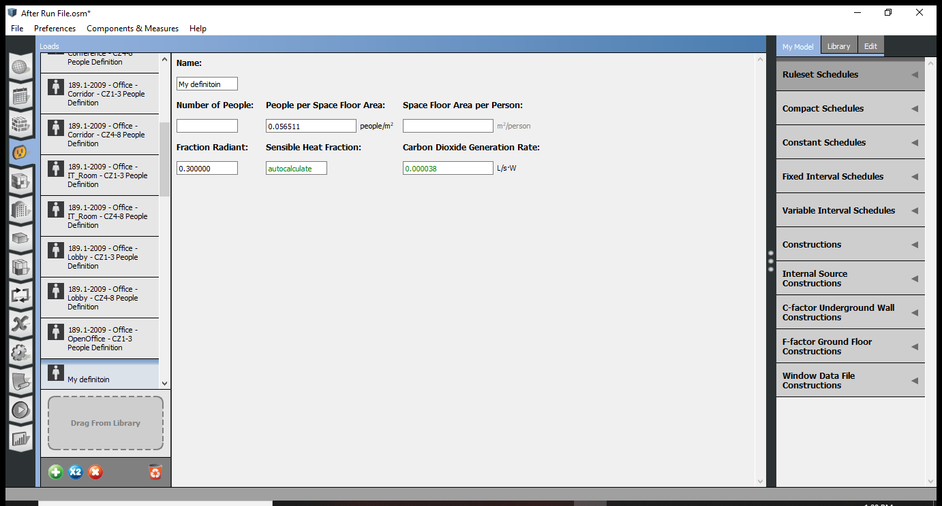

Duplicate and change the loads, then go to the lighting and change the ones for the breakroom and the open office

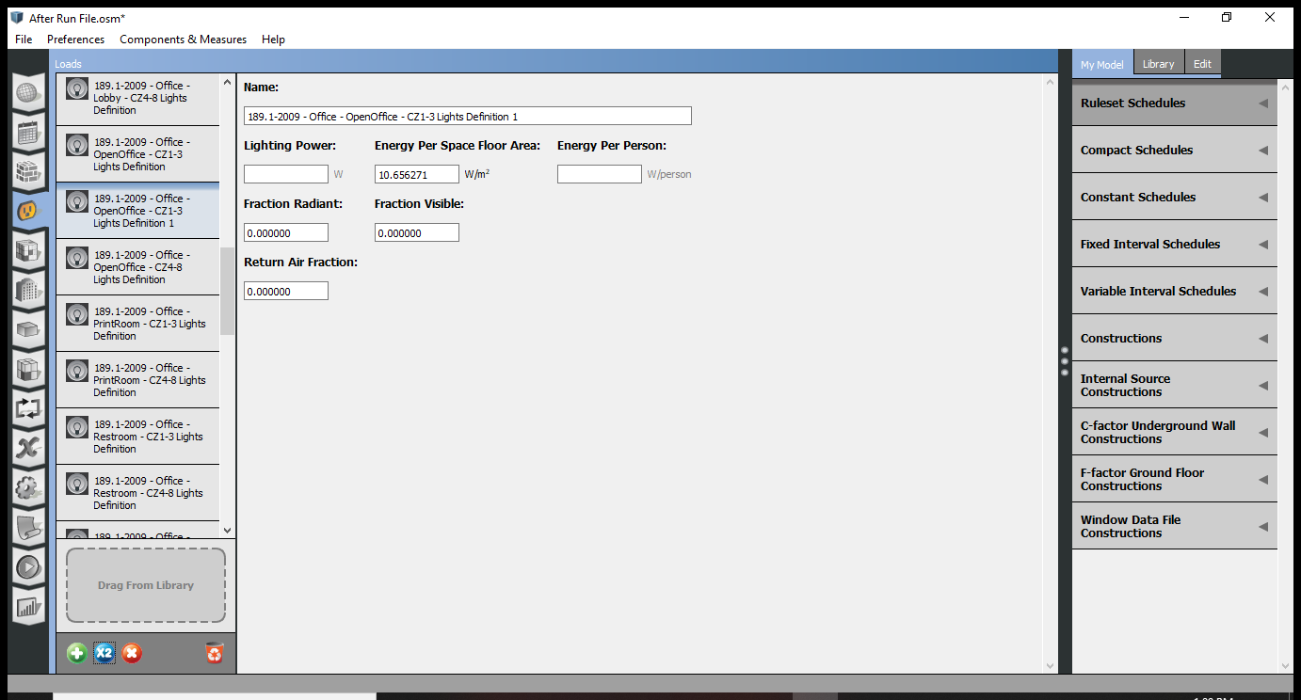

And according look for the loads and if you don’t know then use the default

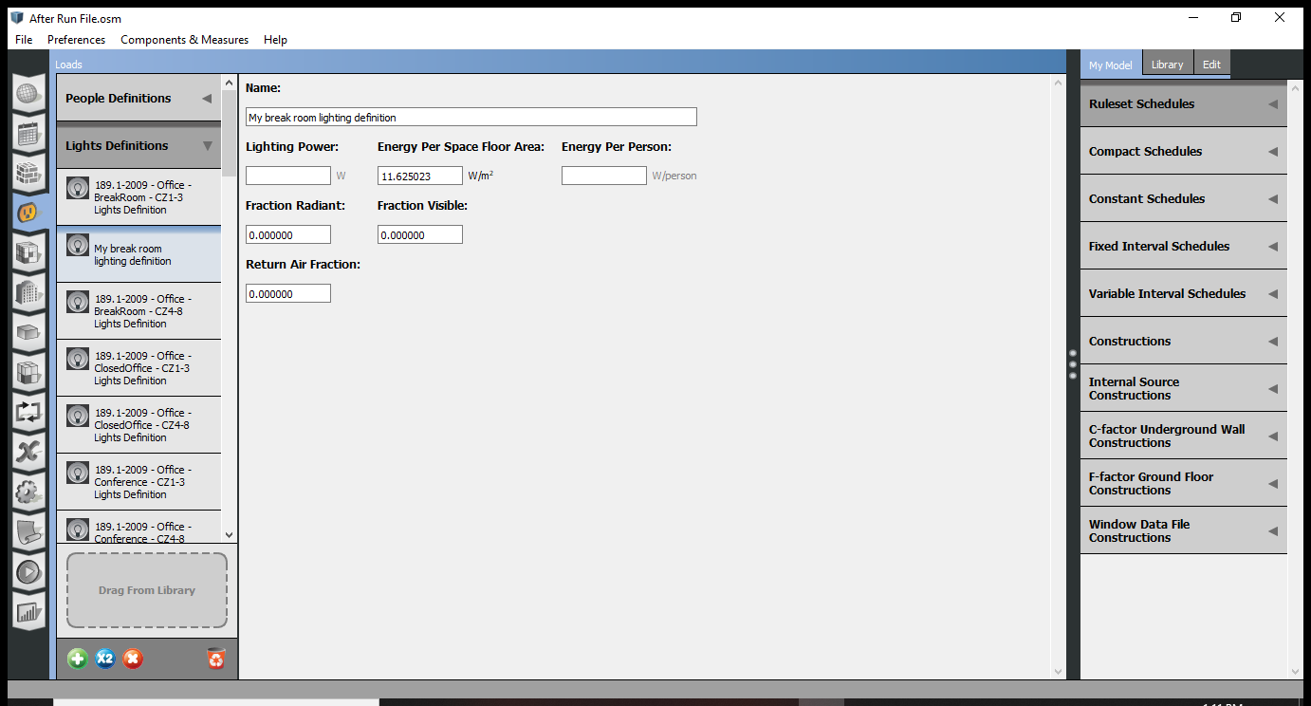

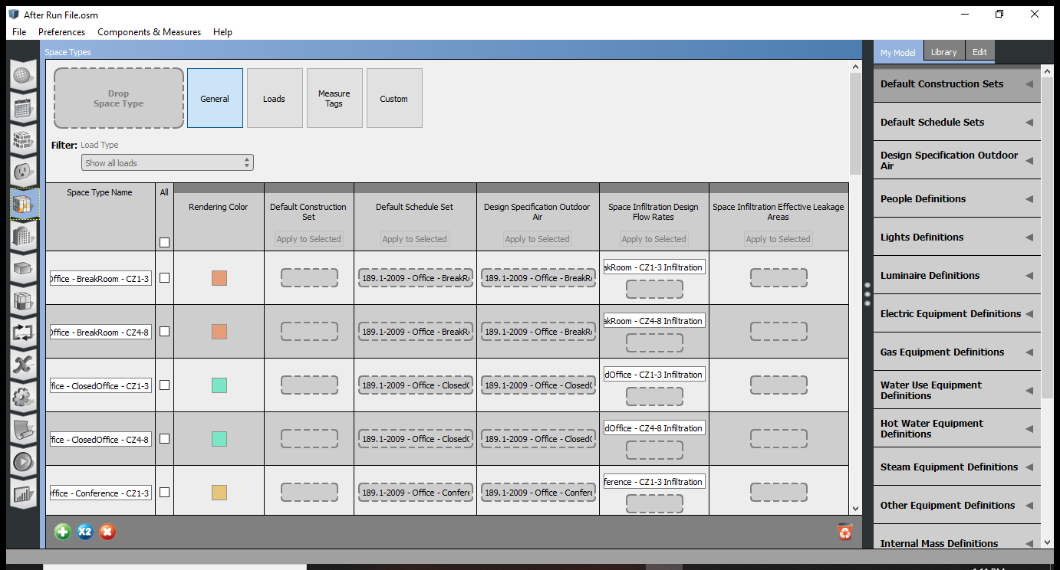

Define spaces and people, make your set ups and choose the set up you did to apply to the model so that the simulation runs according to the new additions.